**1.Issue:**

Accepting Invalid Email Id’s in the POST request (Create User with Roles)

**Description:**

Able to create a new user with invalid email id (Without @symbol,.com) for the userLoginEmail field.

**Screenshot:**

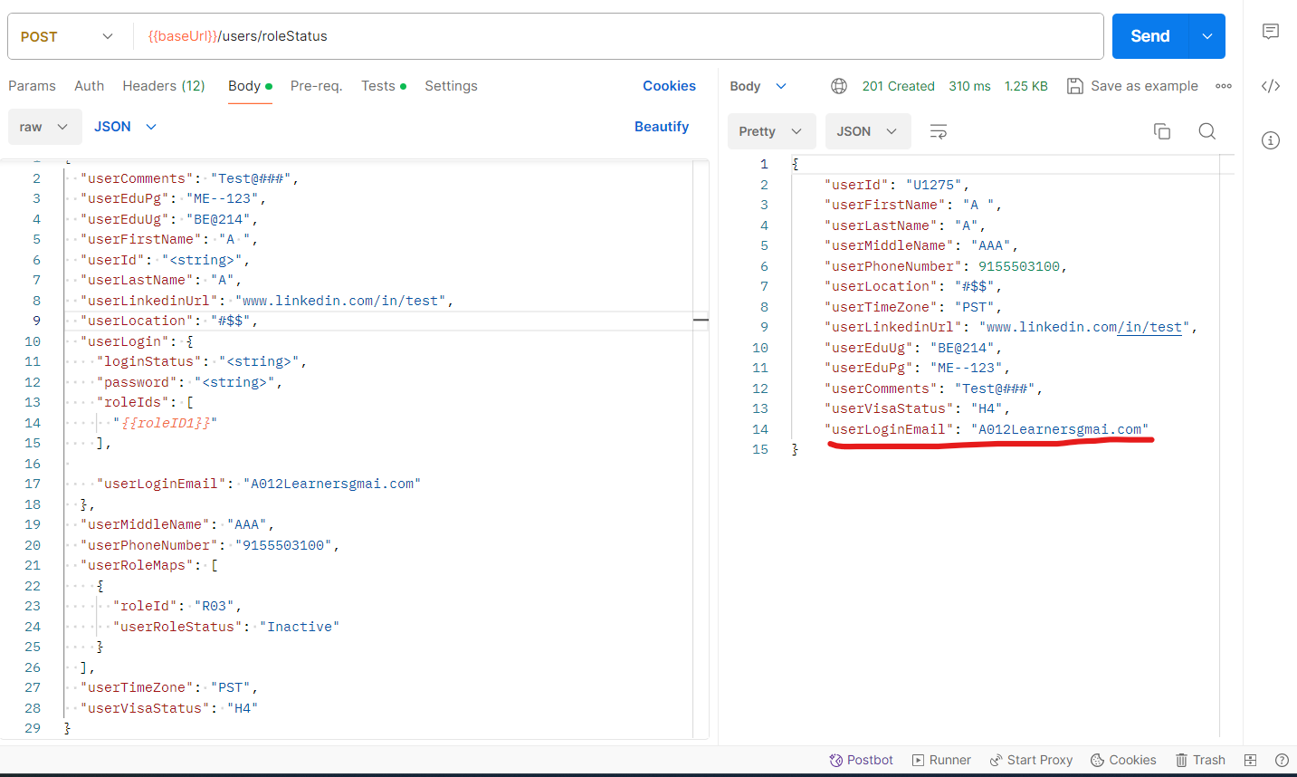

**2.Issue:**

Accepting Invalid data for the Location in the POST request (Create User with Roles)

**Description:**

Able to create a new user with invalid location (Special characters,Numbers) for the userLocation field.

**Screenshot:**

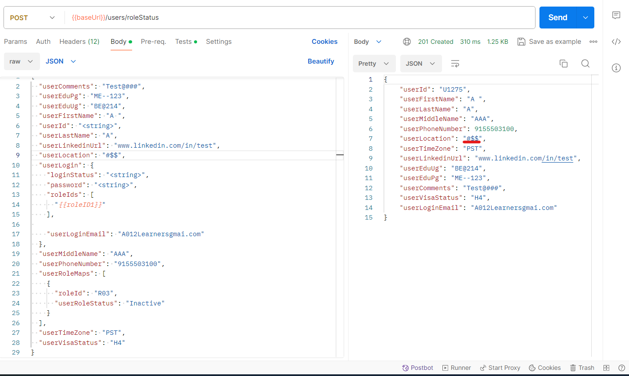

**3.Issue:**

Accepting Single Character for the First Name field in the POST request (Create User with Roles)

**Description:**

Able to create a new user with Single Character for the userFirstName field.As per the message that shows when an user tries to create a new user with invalid First Name (with special characters,numbers) it must accept First Name with 2 or more alphabets.

**Screenshot:**

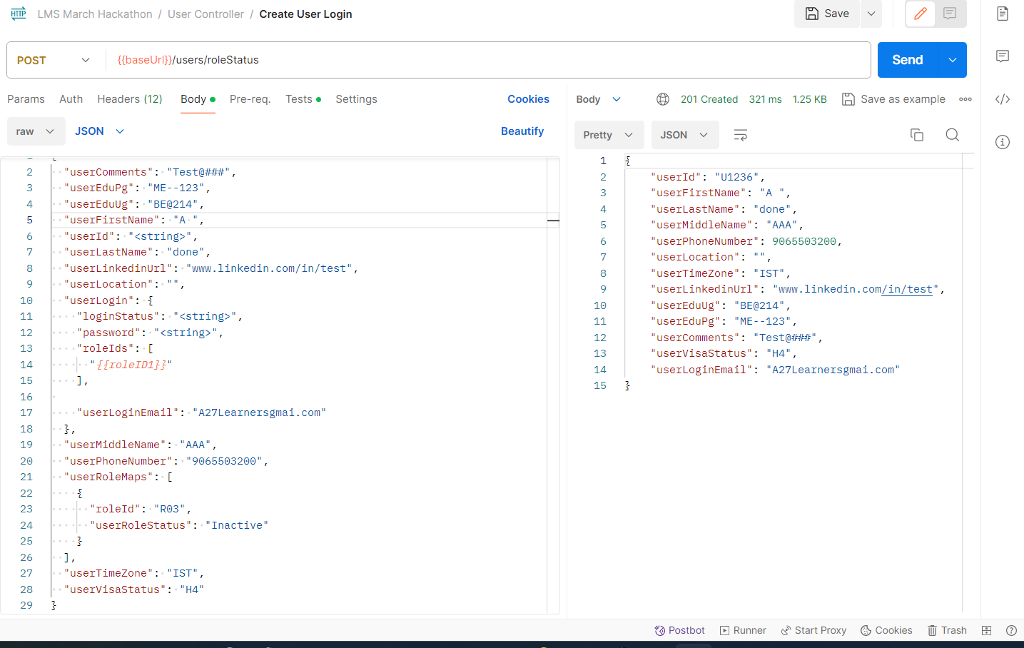

**4.Issue:**

Getting incorrect Status Code for requests while creating requests with existing values for the unique fields.

**Description:**

While creating requests with existing values for the unique fields.(Existing Phone Number, Existing Program Name, Batch Name) instead of getting 409(Conflict) we are getting (400 Bad Request)

**Screenshot:**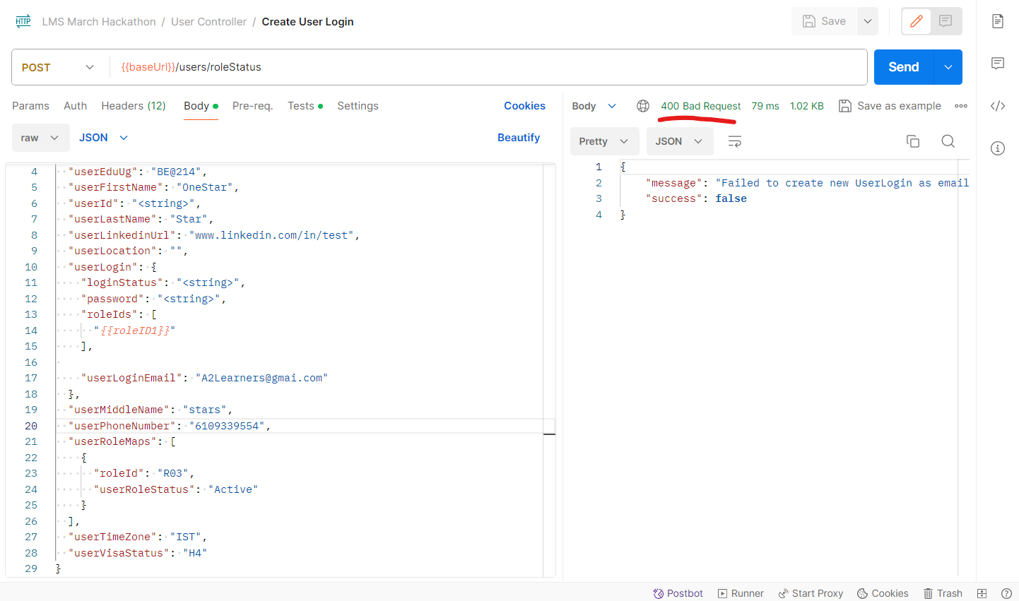

**5.Issue:**

Accepting Invalid data for the PhoneNumber in the POST request (Create User with Roles)

**Description:**

Able to create a new user with invalidPhoneNumber (begins with 0) for the userPhoneNumber field.In the response userPhoneNumber is having only 9 digits.

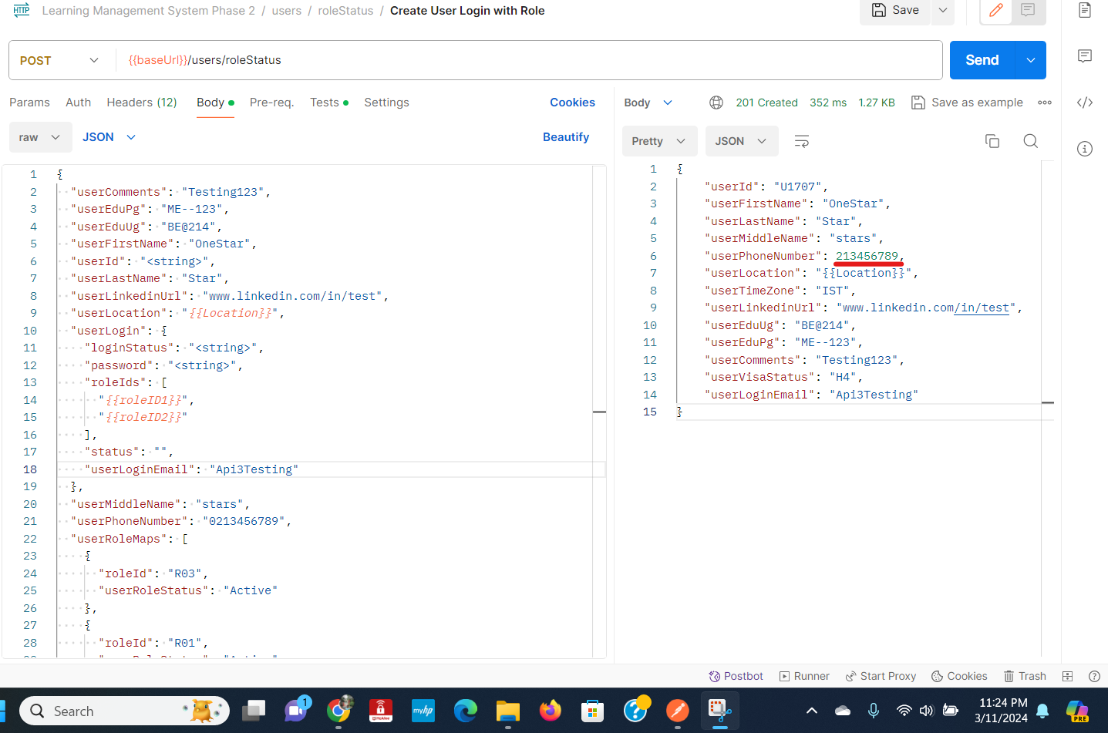



**6.Issue:**

Accepting Invalid data for the Edupg in the POST request (Create User with Roles)

**Description:**

Able to create a new user with invalid Edupg (Special characters) for the userEduPg field. The error message says userEduPg must begin with the alphabet and should contain only AlphaNumeric but it accepts special characters.

**7.Issue:**

Accepting Invalid data for the Eduug in the POST request (Create User with Roles)

**Description:**

Able to create a new user with invalid Eduug (Special characters) for the userEduUg field. The error message says userEduUg must begin with the alphabet and should contain only AlphaNumeric but it accepts special characters.

**8.Issue:**

Accepting Invalid data for the Comments in the POST request (Create User with Roles)

**Description:**

Able to create a new user with invalid Comments (Special characters) for the userComments field. The error message says userComments must begin with the alphabet and should contain only AlphaNumeric but it accepts special characters.

**Screenshot for 6,7,8:**

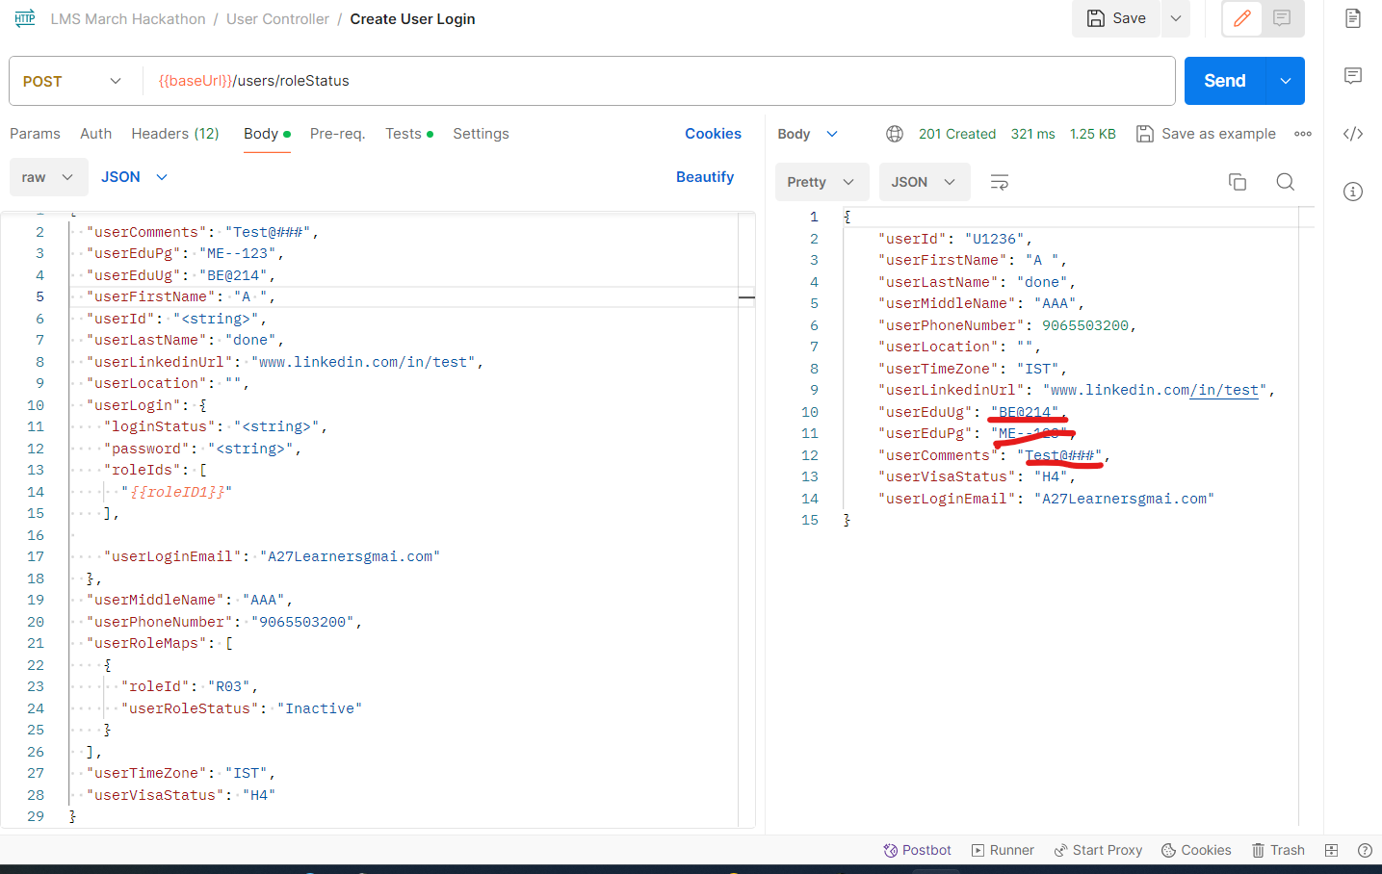

**9.Issue:**

Accepting Invalid data for the FirstName in the PUT request (Put Update UserID)

**Description:**

Able to update users with invalid FirstName (Special characters,Numbers,Alphanumeric) for the userFirstNamefield. In the Post request while creating a user it says useFirstName must contain Alphabets only, however in the Put request it accepts invalid data.

**10.Issue:**

Accepting Invalid data for the LastName in the PUT request (Put Update UserID)

**Description:**

Able to update users with invalid LastName (Special characters,Numbers,Alphanumeric) for the user LastNamefield. In the Post request while creating a user it says userLastName must contain Alphabets only, however in the Put request it accepts invalid data.

**11.Issue:**

Accepting Invalid data for the MiddleName in the PUT request (Put Update UserID)

**Description:**

Able to update users with invalid MiddleName (Special characters,Numbers,Alphanumeric) for the user MiddleNamefield. In the Post request while creating a user it says userMiddleName must contain Alphabets only, however in the Put request it accepts invalid data.

**12.Issue:**

Accepting Invalid data for the EDu fields and user comments in the PUT request (Put Update UserID)

**Description:**

Able to update users with invalid EDu fields and user comments(Special characters,Numbers,Alphanumeric) for the user EDu fields and user comments.

**13.Issue:**

Accepting Invalid data for the PhoneNumber in the PUT request (Put Update UserID)

**Description:**

Able to update users with invalid PhoneNumber (Less than 10-digit,More than 10 digit, Existing phone number, Starts with 0,All 10-digits as 0)for the user PhoneNumber.

**14.Issue:**

Accepting Invalid data for the EmailId in the PUT request (Put Update UserID)

**Description:**

Able to update users with invalid EmailId (Without @,.com)for the userEmailId

**Screenshots for 9,10,11,12,13,14:**

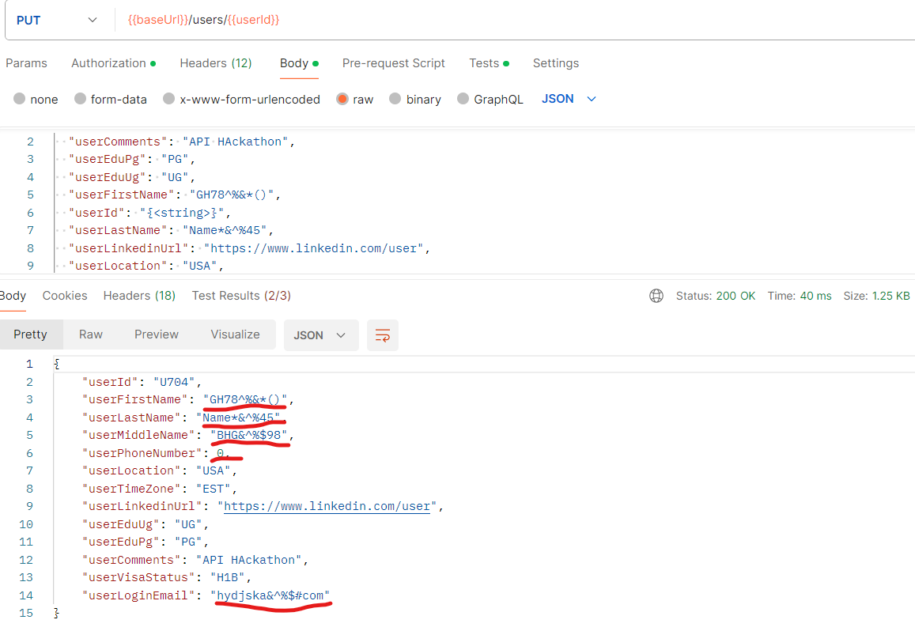

**15.Issue:**

Accepting Invalid data for the Program Name in the POST request (Create Program) **Description:**

Able to create a new user with invalid Program Name (Special characters) for the Program Name field. The error message says Program Name must begin with the alphabet and should contain only AlphaNumeric but it accepts special characters

**16.Issue:**

Accepting Invalid data for the Program Description in the POST request (Create Program)

**Description:**

Able to create a new user with invalid Program Description(Special characters) for the Program Description field. The error message says ProgramDescription must begin with the alphabet and should contain only AlphaNumeric but it accepts special characters

**Screenshots for 15,16:**

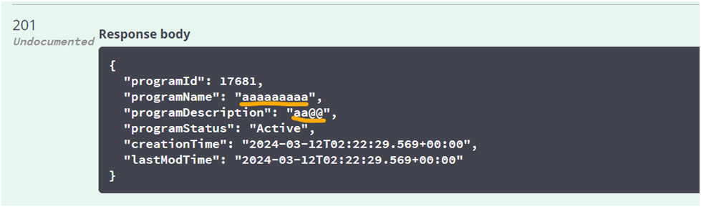

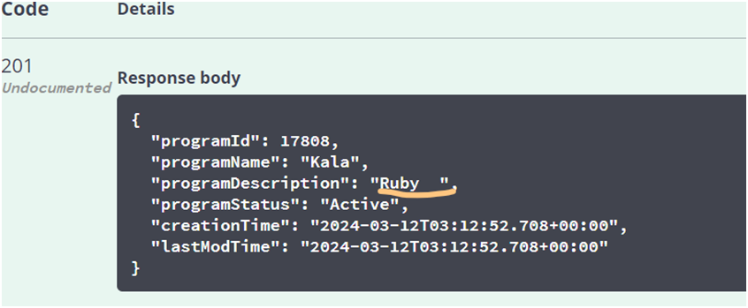

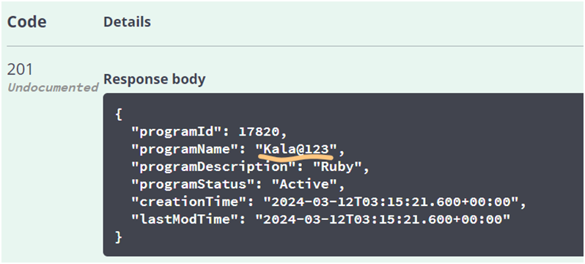

**17.Issue:**

Accepting Invalid data for the Batch Name in the POST request (Create Batch) **Description:**

Able to create a new user with invalid Batch Name (Special characters) for the Batch Name field. The error message says Batch Name must begin with the alphabet and should contain only AlphaNumeric but it accepts special characters

**18.Issue:**

Accepting Invalid data for the Batch Description in the POST request (Create Batch)

**Description:**

Able to create a new user with invalid Batch Description(Special characters) for the Batch Description field. The error message says Batch Description must begin with the alphabet and should contain only AlphaNumeric but it accepts special characters

**Screenshots for 17,18:**

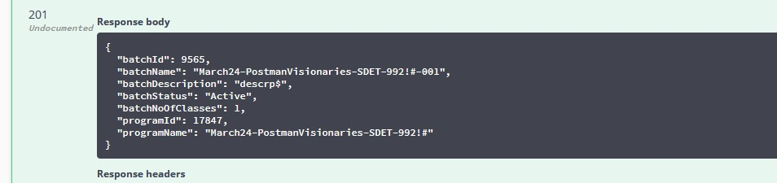

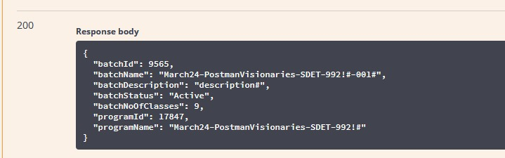

**19.Issue:**

Not Accepting existing email id for the user role in the POST request (Create User role)

**Description:**

Not able to create a new user with existing Email ID for the user_LoginEmail field. The error message says User cannot be created as user Login Email already exists. But in the document this field is not mentioned as unique like a phone number.

**Screenshot:**

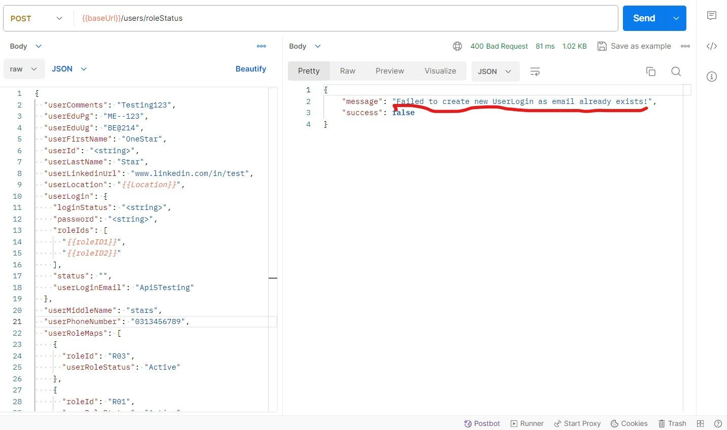

**20.Issue:**

Not Accepting existing Program name for the program controller module in the POST request (Create Program)

**Description:**

Not able to create a new program with an existing program name for the Name field. The error message says Program cannot be created as Name already exists. But in the document this field is not mentioned as unique.

**Screenshot**

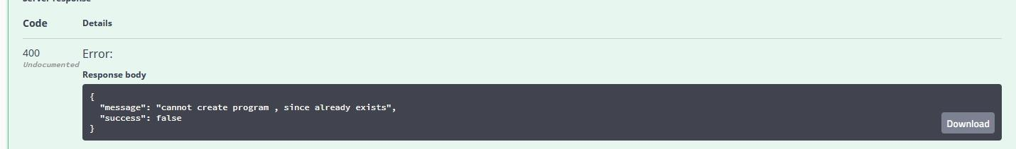

**21.Issue:**

Not Accepting existing Batch name for the Batch module in the POST request (Create Batch)

**Description:**

Not able to create a new Batch with an existing Batch name for the Name field. The error message says Batch cannot be created as Name already exists. But in the document this field is not mentioned as unique.

**Screenshot**:

